Greetings Walter Bracken Families:
I am honored to be serving as the Assistant Principal at Walter Bracken STEAM Academy for the 2019-2020 school year. I am a 24-year veteran educator from Euclid, Ohio. I earned my Bachelor of Science Degree in Education in 1996, from Ohio University-Athens, a master’s degree in the Art of Teaching in 2002, from Marygrove College-Detroit, Michigan, and a master’s degree in the Arts of Education; Administration and Supervision in 2007, from the University of Phoenix-Las Vegas. Currently, I am a first-year doctoral candidate at Capella University. Prior to administration, I served 13 years as a primary and intermediate teacher and Learning Strategist. I am married with 2 college students, Taylor and Trisden, and I have two dogs, a Maltese-Chelsea, and a Yorkie-Neiko. I am very active in a variety of civic and cultural organizations including Alpha Kappa Alpha Sorority, Incorporated, Kappa Delta Pi Educational Fraternity, The Girlfriends, The Society and my church. Outside of professional and social interests, my hobbies include dancing, painting, and attending plays/musicals. I also love shopping, attending sporting events, reading, and traveling. I look forward to working this year with the students and families and learning all about the Bracken community! It’s going to be a great year!
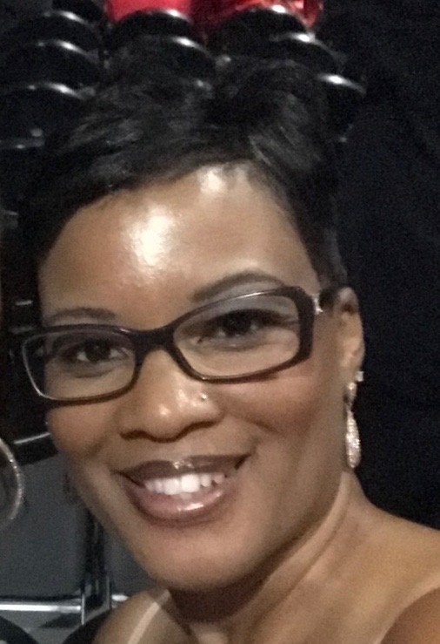
~Mrs. Erica L. Silas

