Name: ____________
Summer Book Challenge!
With your reading book bag, keep reading over the summer holidays and cross off the boxes you complete! Good luck!
Bring this completed BINGO back to your third grade teacher to receive a ‘cool treat’!
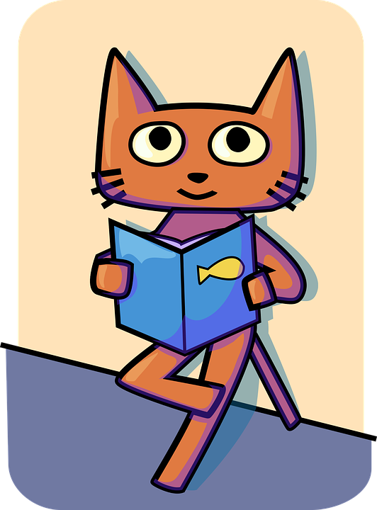  Read one book to your soft toy or teddy bear. | Create an animal themed bookmark. | Fill out the ‘Story Map’ in your Reading Journal for one of your books. | Read a book in your garden.
Solve the wordsearch in you Reading Journal. | Read the Octopuses book and complete the ‘Informational Text’ page of your Reading Journal. | Choose a book to act out for your family. | Redesign one of the book’s covers.
Choose one of your books to fill out the ‘Summary’ page of your Reading Journal. | 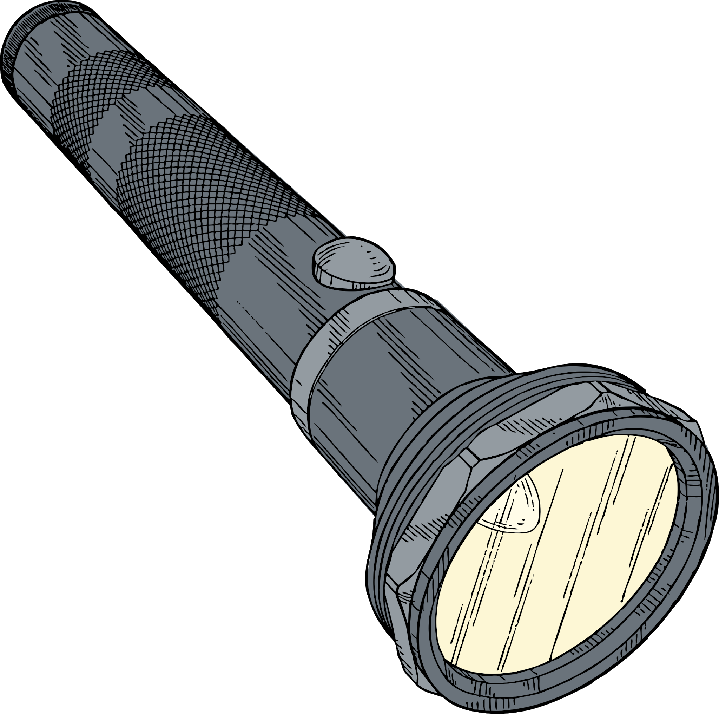  Read a book then make it into a comic strip. | Compare and Contrast two of your books using the page in your Reading Journal. | Write a letter to your favorite book character telling them about your summer holidays.
Complete the ‘Activity Page’ jigsaw in your Reading Journal by drawing your favorite part of one of the books you have read. | Read a book in the dark with a flashlight. | Draw your own version of the Mola Lisa! | After reading “Hank the Pet Sitter’, write a story about Otis’s next adventure!
After reading ‘To the Moon’, make your own Moon Diary. | After reading ‘Cheetah Vs. Tortoise’, write down five things you found out. | Complete the ‘Character Analysis’ page of your Reading Journal for one of your favorite book characters. | Convince me to read your favorite book in your book bag by completing the “Opinion’ page of your Reading Journal.

